Underground Cable Rating Cover Sheet

*This document is to be used as a template for submitting a rating assessment to be reviewed by Ausgrid. It does not need to be used, but all aspects of this template should be included in the rating submission.*

Yellow highlighted text are examples

*Instructions are in Italics; they do not need to be included in the submission.*

*Note: if the cable you are assessing comes within 4m of an Ausgrid asset you will need to request a Rating to be Maintained (RTBM) from Ausgrid.*

|  |  |
| --- | --- |
| Project Name: | New 11kV Feeder |
| Ausgrid Project number: | - |
| RSQR Report Number:  (If known) | 2020 – 065A |
| Date of last submission: | *Only required if another rating assessment has been submitted for review for this project* |
| Submission contact details: |  |

**Table of Details for endorsement:**

| **Endorsement** | **Details** | **Comments** |
| --- | --- | --- |
| **Cable** | New 11kV feeders: 11kV 630mm2 Cu XLPE insulated Single core cable |  |
| **Bonding** | Single Point Bonding |  |
| **Target Ratings** | Proposed Connection -  Each feeder has 2 cables  Feeder to achieve Ratings of 2000A (normal) |  |

**All Underground Ratings Submission MUST include:**

* Design Drawing compliant with NS 104.
* Cymcap models (MDB File) if available, these are the computer files of the models used to assess the ratings.
* Cable Verifications for every cable used in models.
* Cable Route.
* All Cross Sections.
* All Ratings Calculations.
* TR Test reports
* Location of TR trial holes
* Any request for dispensation.

***Please note:***

*Ausgrid will review all submissions as soon as possible, however, there may be instances of delay when the submission is incomplete or where further information may be required.*

*You will be notified if any further information is required.*

*Where there is an incomplete submission or further information has been requested, ratings assessment will be put on hold until all information requested has been provided*.

Underground Cable Rating Submission

Underground Cable Rating Submission Template (for submissions with accompanying Cymcap model).

# **1. Cable Verification**

*Perform cable verification for every cable found in your model to the following conditions and present the results.*

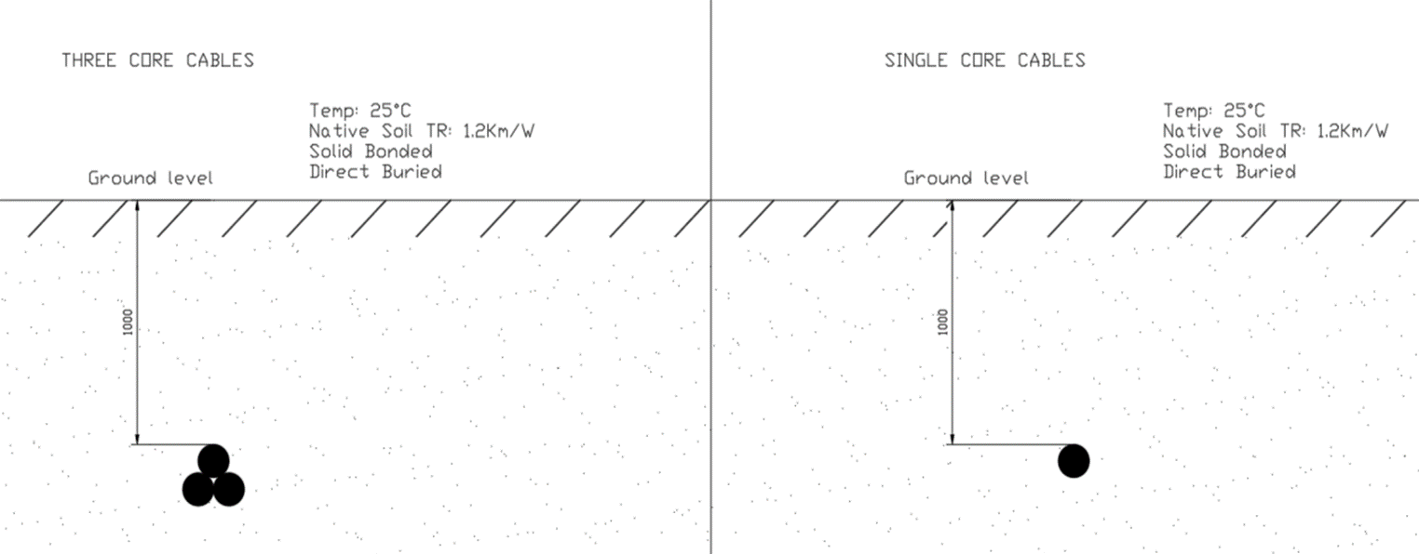

***NS272 s8.0:*** *All individual cable models must be formally verified against the manufacturer’s data sheets for the cables, regardless of the ratings software used. This verification documentation must form a part of the electrical design.*

|  |  |  |  |  |  |
| --- | --- | --- | --- | --- | --- |
| **Cable ID** | **Cable Name /Cable Size / Type** | **Conductor Temperature [°C]** | **Ampacity Achieved by ASP [A]** | **Ampacity Achieved by Manufacturer  (If known) [A]** | **Ampacity Achieved by Ausgrid (If known) [A]** |
| *Cable 0 (Example)* | *G3-11 - 500CU3 XLPE* | *90.0* | *607.5* | *610* | *610* |
| Cable 1 | C011-547 | 90.0 | - | - | 662 |
| Cable 2 |  |  |  |  |  |
| Cable 3 |  |  |  |  |  |
| Cable 5 |  |  |  |  |  |
| Cable 6 |  |  |  |  |  |

# **2. Standard Cross Section Validation**

*Select one cable from the cable verification table.*

*Construct a typical cross section using the following details.*

*Perform Cross section verification simulation and present the results, this confirms correct use of the ratings calculation tool.*

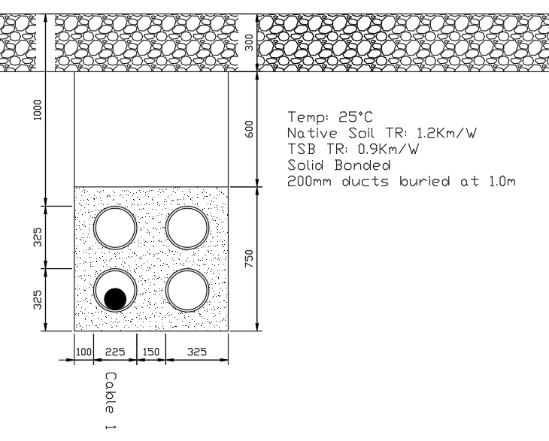

|  |  |  |  |  |
| --- | --- | --- | --- | --- |
| **Cable ID** | **Cable model** | **Normal (A)** | **Temperature (°C)** | **Comments** |
| Cable 1 | C011-547 | 593 | 90 |  |

# **3. Ratings Calculation Review**

***See NS272 s9.0:*** *You will be required to provide the following for assessment:*

* *The assumptions used.*
* *The entire cable route.*
* *The identified cross sections for ratings analysis.*
* *Design drawings including cross sections. The Cross-section ID in models must match design drawings.*
* *Thermal Resistivity test reports.*
* *Design must comply with NS130, 168 and 272.*
* *Manage the risk of dry out by ensuring the 50°C isotherm is fully within the thermally stable material or fully dried TR is used with the 50°C isotherm.*

*For each identified cross* *section, construct the cross section in Cymcap and perform ratings simulation and present the results in a summary table.*

*Where necessary, please state the assumptions used in your ratings assessment.*

3.1 Assumptions and Target ratings

|  |  |  |
| --- | --- | --- |
|  | Summer | Winter |
| Ambient Ground Temperature: | 25°C | 18°C |

|  |  |
| --- | --- |
| Description | Value |
| Sheath/Shield Bonding: | Single Point Bonded |
| Target Ratings: | 2000A Per Leg (Normal) |

3.2 Relevant Thermal Resistivity Test Reports

|  |  |  |  |  |
| --- | --- | --- | --- | --- |
| Cross Section | TR Test Location | TR @ 3% Moisture content | Fully Dried TR (Km/W) | Comments |
| Backfill | - |  | 0.9 |  |
| Section 7 248524 | TH2 | 2.35 | 2.91 | Test Report: 141901 rev2 |
| - | TH1 | 0.86 | 1.11 | Next closest Trial hole |

3.3 Cable Route, TR Trial Holes & Cross Section Location

*Attach plan view of cable route with cross section location identified* *and TR Trial Hole locations. TH1 – trial hole 1*

TH 1

Case 2

**

Case 3

TH2

Case 1

**Destination Substation**

**Source Substation**

3.4 Design Review

*The basic requirement will be that all Cymcap models must match the design drawings.*

*Provide commentary on design / cross sections (if required).*

*Attach details* ***for every Cross section*** *identified in the cable route*

Case 1

Drawing: 248525_03R1.pdf

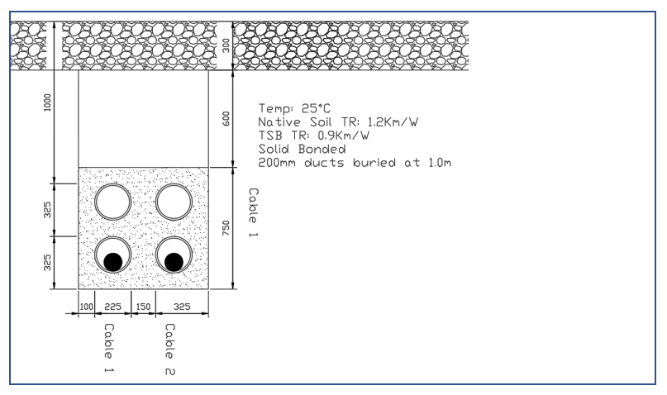

Case 2

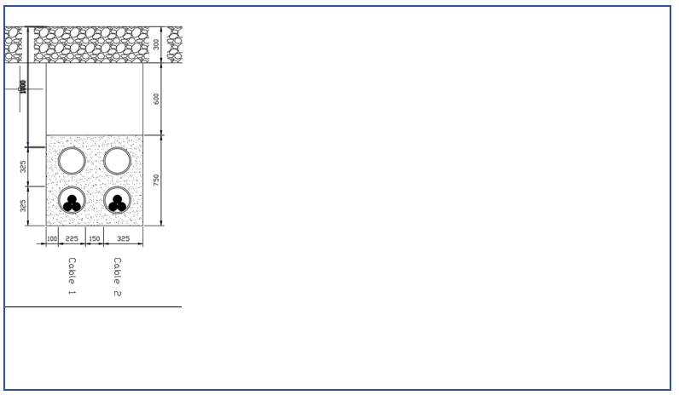

3.5 Ratings Calculation Table (If Required)

Summer Continuous rating table.

|  |  |  |  |  |  |  |
| --- | --- | --- | --- | --- | --- | --- |
| **Case** | **Cable ID** | **Normal (A)** | **Temperature (°C)** | **Abnormal (A)** | **Temperature (°C)** | **Comments** |
| 1 | Cable 1 | 603 | 90 | - | - | Both Cables in Service |
| - | - | 667 | 90 | One Cable in Service |
| 2 | Cable 1 | 603 | 90 | - | - | Both Cables in Service |
| - | - | 667 | 90 | One Cable in Service |

Winter Continuous rating table.

|  |  |  |  |  |  |  |
| --- | --- | --- | --- | --- | --- | --- |
| **Case** | **Cable ID** | **Normal (A)** | **Temperature (°C)** | **Abnormal (A)** | **Temperature (°C)** | **Comments** |
| 1 | Cable 1 | 635 | 90 | - | - | Both Cables in Service |
| - | - | 696 | 90 | One Cable in Service |
| 2 | Cable 1 | 635 | 90 | - | - | Both Cables in Service |
| - | - | 696 | 90 | One Cable in Service |

3.6 Ratings Summary

*Perform ratings assessment and present the results:*

|  |  |  |  |  |
| --- | --- | --- | --- | --- |
| **Season** | **Rating Type** | **Scenario** | **Amps per cable (A)** | **Continuous Rating per Feeder (A)** |
| Summer | Normal | Both feeders in service | 603 | 1809 |
| Emergency | 1 feeder in service | 667 | 2001 |
| Winter | Normal | Both feeders in service | 635 | 1905 |
| Emergency | 1 feeder in service | 696 | 2088 |

# **4 Conclusion**

*Provide some commentary on the ratings calculation / assessment and state your opinion whether your design has achieved the ratings objective.*

*This is also an opportunity for you to provide us any further information that you might want to draw our attention to.*

*Note: if the cable you are assessing comes within 4m of an Ausgrid asset you will need to request a Rating to be Maintained (RTBM) from Ausgrid.*

*Note – Request RTBM document from Ausgrid if required.*

# **5. Appendix**

*Attach any other reports or supporting documentations. These can be (but not limited to):*

* *Cymcap outputs (Excel files, example found on web)*
* *TR Test reports*
* *TR Trial hole location*
* *Earthing Reports etc.*